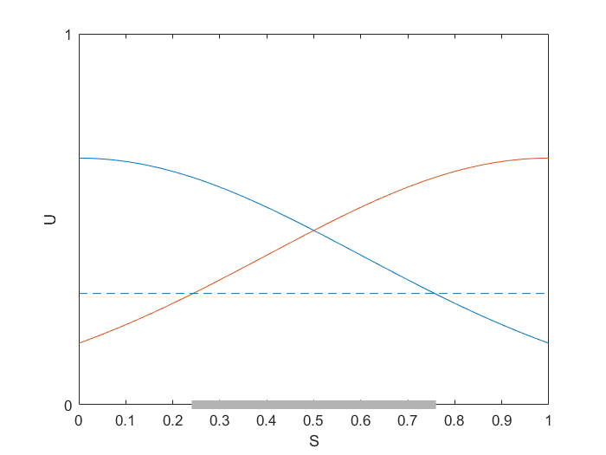

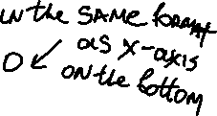

Fig. 7 Two identical utility functions (S = [0 1])

**NOTE list of changes:**

Label two utility functions K1(x) and K2(x) – in different color as shown

Use *different* threshold values C1 and C2 for each K1(x) and K2(x)

Shift x-axis UP, so that all K-values shown are in the range [0,1]

(the shaded portion of x-axis will change due to different values C1 , C2)

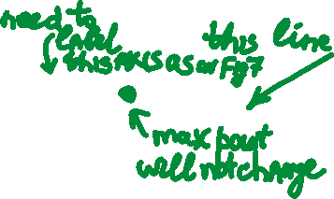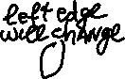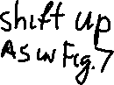

Fig. 8 Sum of two identical utility functions (S = [0 1])

**List of changes for Fig 8:**

* Shift the x-axis UP as in Fig 7 and
* *make other changes* consistent with Fig 7.
* No need to show C1 and C2
* *Do not* re-label upper x-axis as in Fig 7.

**For all remaining Figs below:**

* Make similar changes as above

*make other changes* consistent with Fig 7

**Actually: I just noticed** that you already *did lift UP x-axis* in Figs 7(a) -10(a), so you just need to modify Figs 7(a) to 10(a) *only*, but re-label the range for K-values from [0.3, 1] to [0, 1]

* Also, use *different* values for C1 and C2 – the chosen values *do not* have to be the same in all figs. You can choose

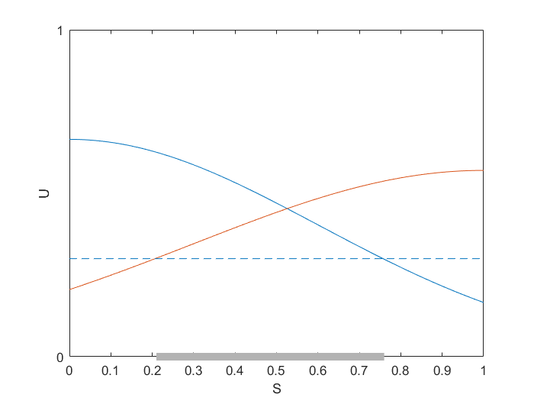

Fig. 9 Two utility functions with different widths (S = [0 1])

Fig. 10 Sum of two utility functions with different widths (S = [0 1])

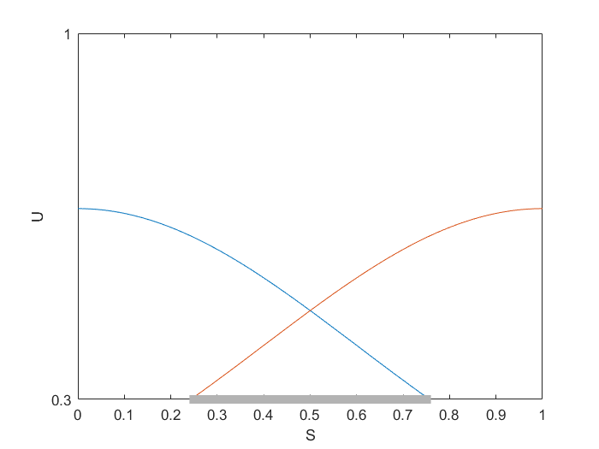

Fig. 7A Two identical utility functions (S = [0 1], U = [0.3 1])

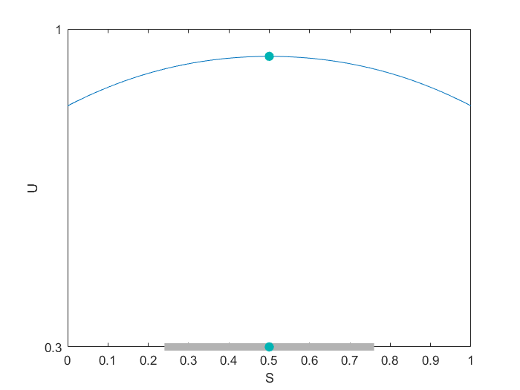

Fig. 8A Sum of two identical utility functions (S = [0 1], U = [0.3 1])

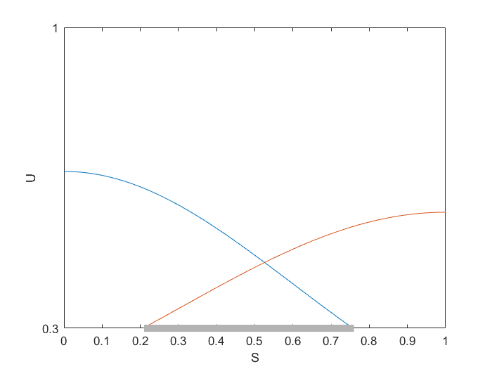

Fig. 9A Two utility functions with different width (S = [0 1], U = [0.3 1])

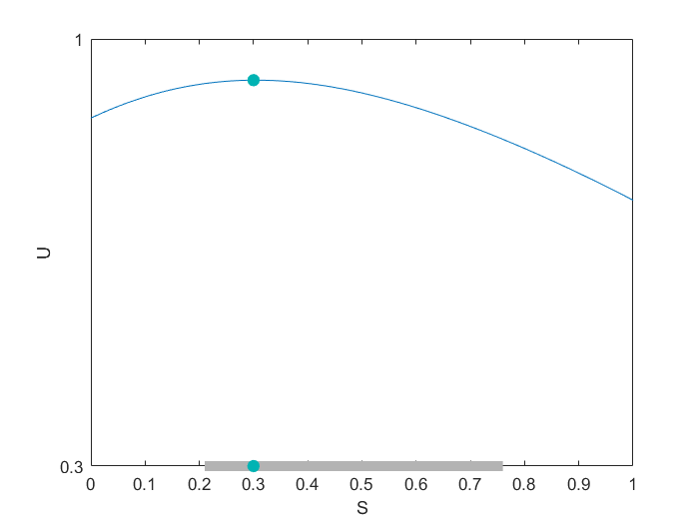

Fig. 10A Sum of two utility functions with different widths (S = [0 1], U = [0.3 1])